





Q4.

(a)

(b)

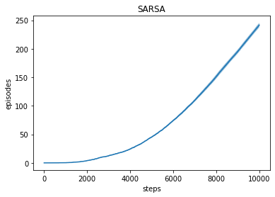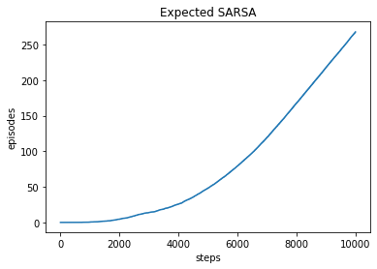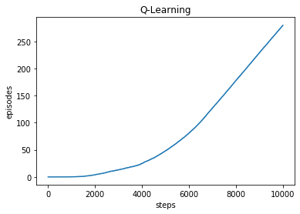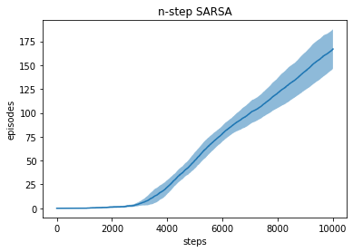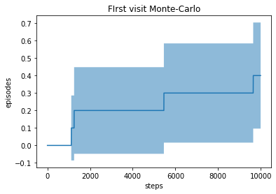

Performance: Q-Learning > Expected Sarsa > Sarsa > n-step Sarsa > First visit Monte-Carlo

(c)

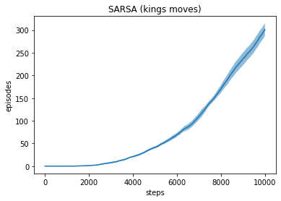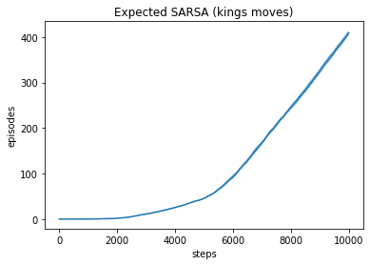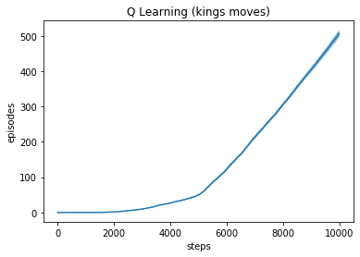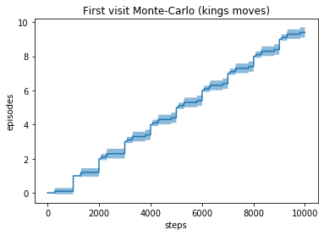

After changing action space to king’s moves, all the methods achieved much better performance (Sarsa by 20%, Expected Sarsa by 55%, q-Learning by 90%, and MC by 30 times, although it’s still very low and basically learned nothing). Before changing, the minimum distance that from the start to the goal is 17 steps and after changing the minimum distance is 7 steps. They still follow the pattern:

Q-Learning > Expected Sarsa > Sarsa > Monte-Carlo

I don’t think including a ninth move will further improve the performance, because staying at the same location will always result in a longer episodes ( at best you may be transit up by one or two steps by the wind and approach the goal, but you can always move left, right, or up to make it even closer).

(d)

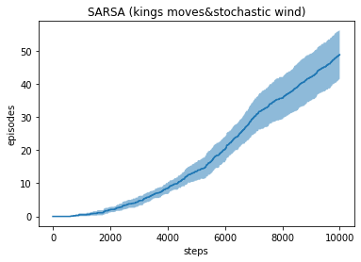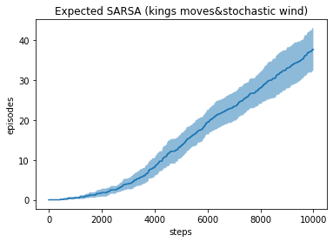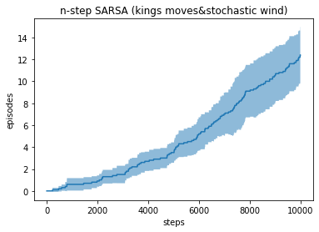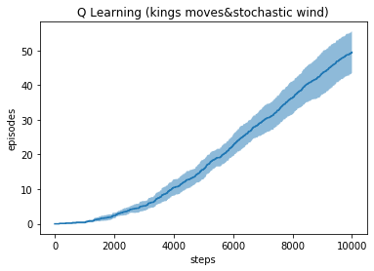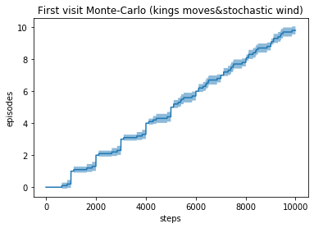

Variance increased, and performance dropped in all methods, caused by the stochastic wind, while Monte-Carlo remains the same because it still learns nothing.

Q5.

(a)

Evaluation graphs after one single run on N episodes:

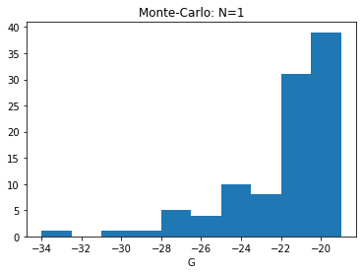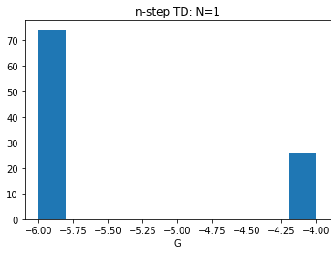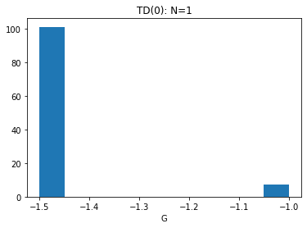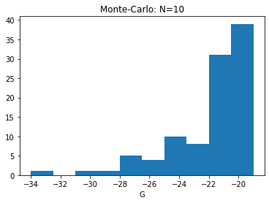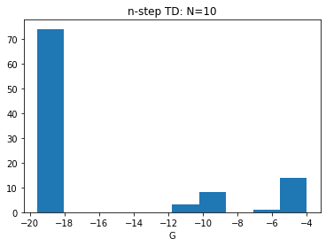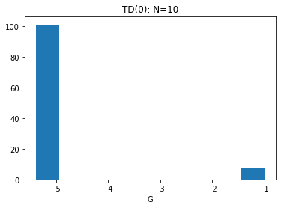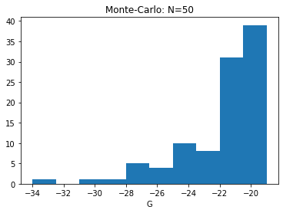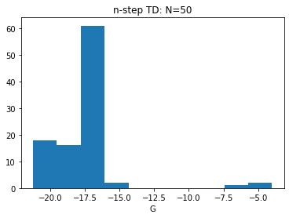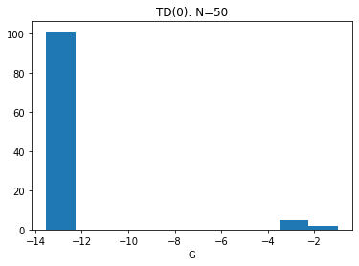

Evaluation graphs after the state values converged, based on N episodes (dashed line indicates true value of the state, calculated by Dynamic programming, V(s) = -19.42):

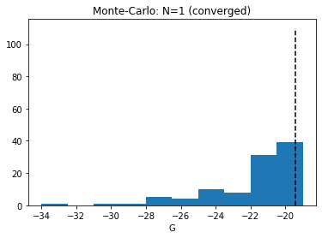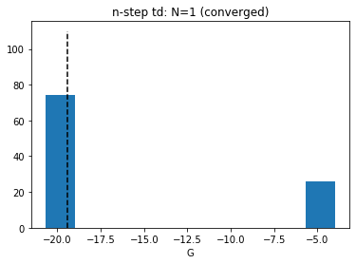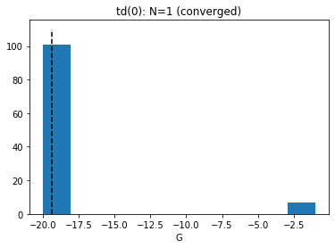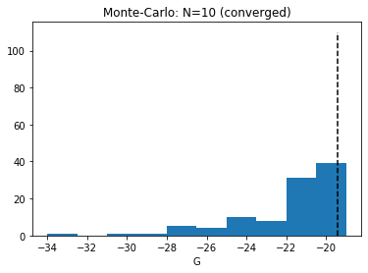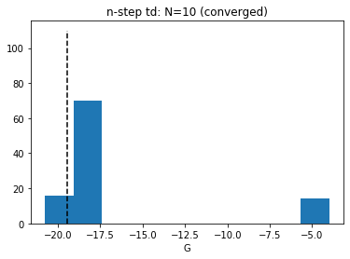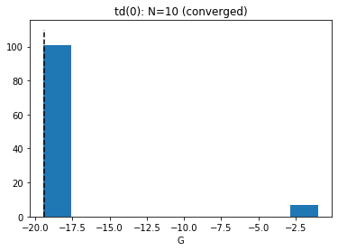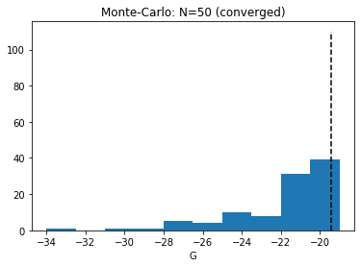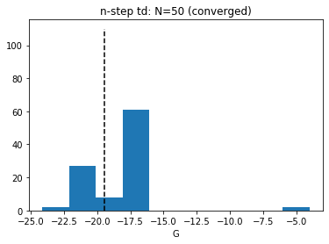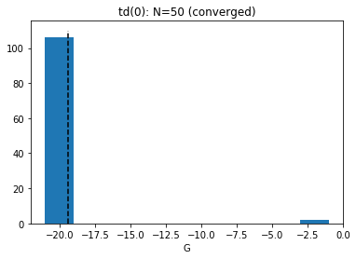

(b)

During the training phase, Monte-Carlo provides the most accurate value estimation (lowest bias) while the largest variance, and TD(0) provides the most stable one (lowest variance) but highest bias, and N-step TD is between these two. After the state value is converged, the bias of TD(0) and N-step TD decreased while Monte-Carlo is still the one with largest bias, and its variance remains the same.

Monte Carlo is unaffected by training set, because it doesn’t need state value to do bootstrapping, whereas the other two methods performs better when the training sets grow larger, because TD methods always have bias in practice and providing larger training dataset will make the value converge to the true value asymptotically.